IMPLEMENT RANDOM FOREST AND ANALYZE PERFORMANCE

AIM
To build a Random Forest Classification model to predict students' results based on hours studied, attendance, and assignments, and evaluate its performance using accuracy, confusion matrix, and classification report.

ALGORITHM
- Import the required libraries: Pandas, Matplotlib, and the necessary functions from Scikit-learn.
- Load the dataset from the CSV file data.csv.
- Select Hours_Studied, Attendance, and Assignments as input features.
- Select Result as the target variable.
- Split the dataset into training and testing sets using an 80:20 ratio with random_state=42.
- Create a Random Forest Classifier with 100 decision trees using RandomForestClassifier(n_estimators=100, random_state=42).
- Train the model using the training data with fit().
- Predict the results for the test data using predict().
- Calculate the model's accuracy using accuracy_score().
- Display the confusion matrix using confusion_matrix().
- Generate the classification report using classification_report() to display precision, recall, F1-score, and support.
- Extract feature importance values using model.feature_importances_.
- Plot a bar graph showing the importance of each input feature.
- Display the feature importance graph using plt.show().
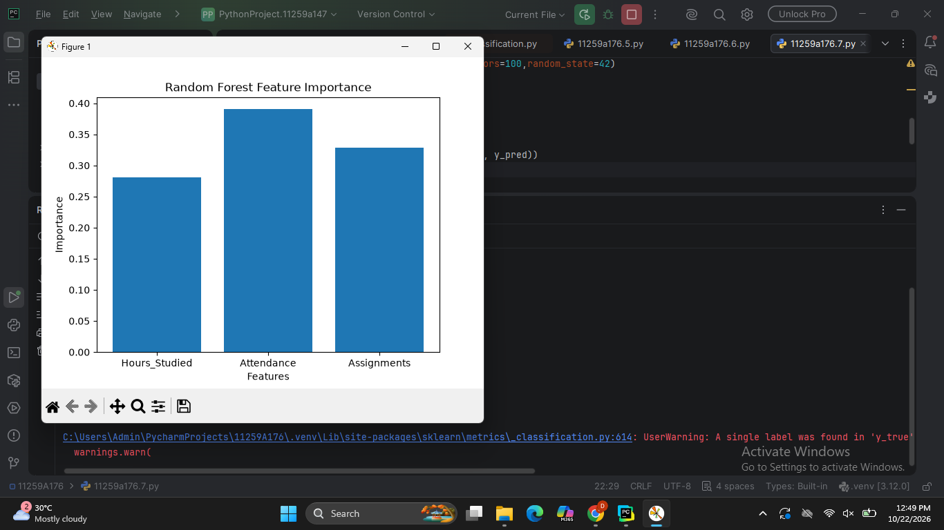

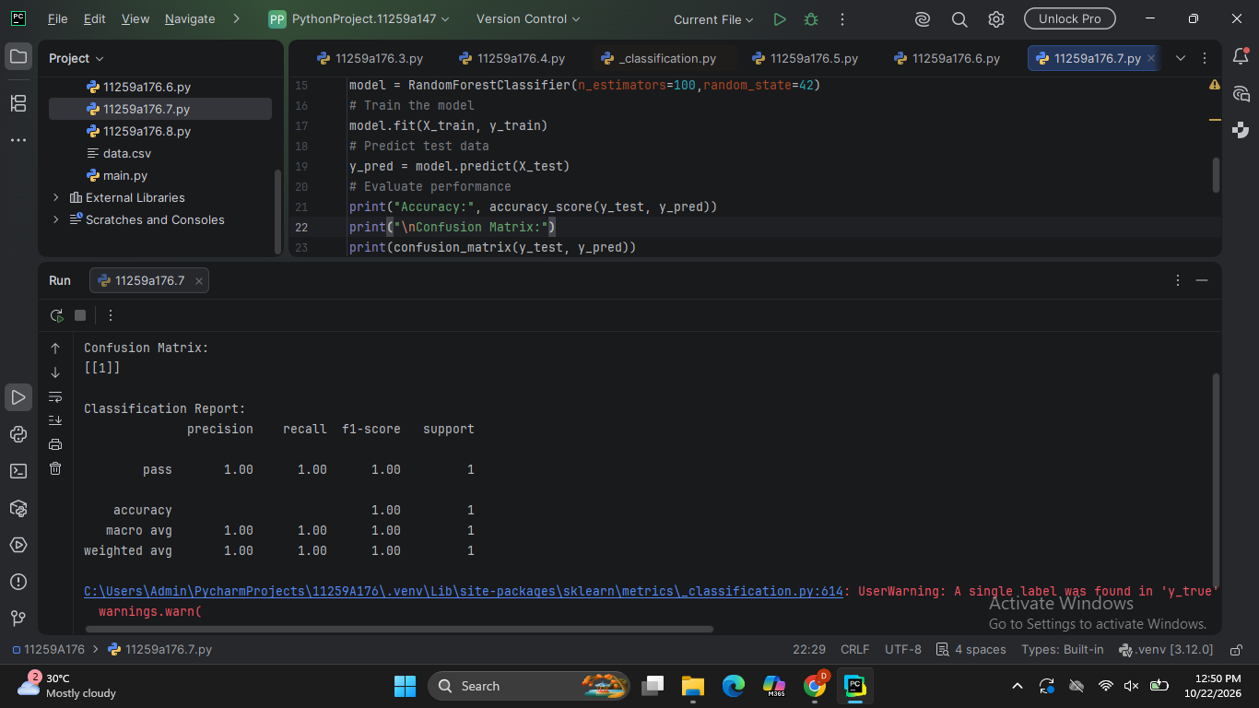

RESULT
The Random Forest Classification model was successfully implemented to predict students' results based on hours studied, attendance, and assignments. The model's performance was evaluated using accuracy, a confusion matrix, and a classification report. A feature importance graph was plotted to identify the contribution of each input feature to the predictions.

